**TEST IMPRESORA**

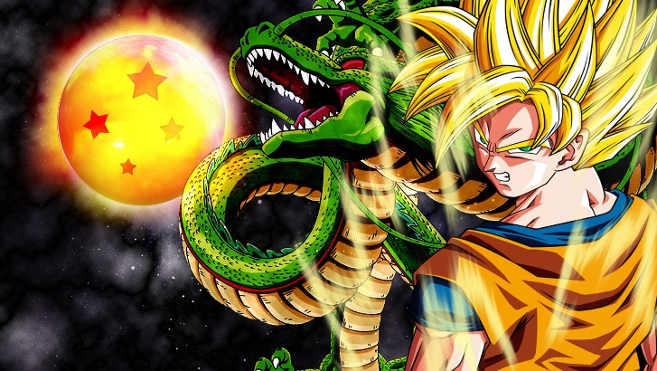

Dragon Ball es un manga escrito e ilustrado por Akira Toriyama. Fue publicado originalmente en la revista Shōnen Jump, de la editorial japonesa Shūeisha, entre 1984 y 1995.

|  |  |  |  |  |  |
| --- | --- | --- | --- | --- | --- |
|  |  |  |  |  |  |
|  |  |  |  |  |  |
|  |  |  |  |  |  |

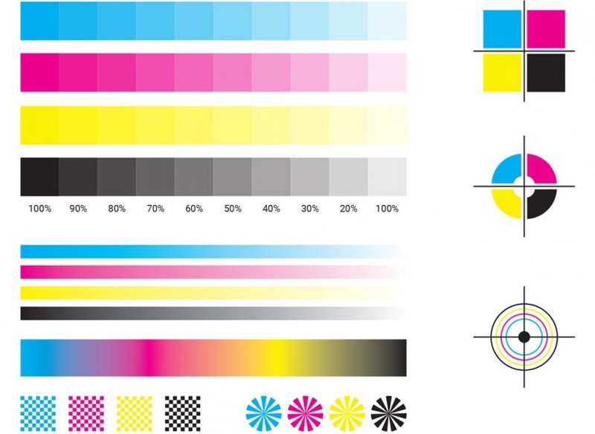

|  |  |  |  |  |
| --- | --- | --- | --- | --- |
| A | B | C | D | E |
| AAAA | BBBB | CCCC | DDDD | EEEE |
|  |  |  |  |  |

